**Ethereal – MYTH**

**MYTH description**

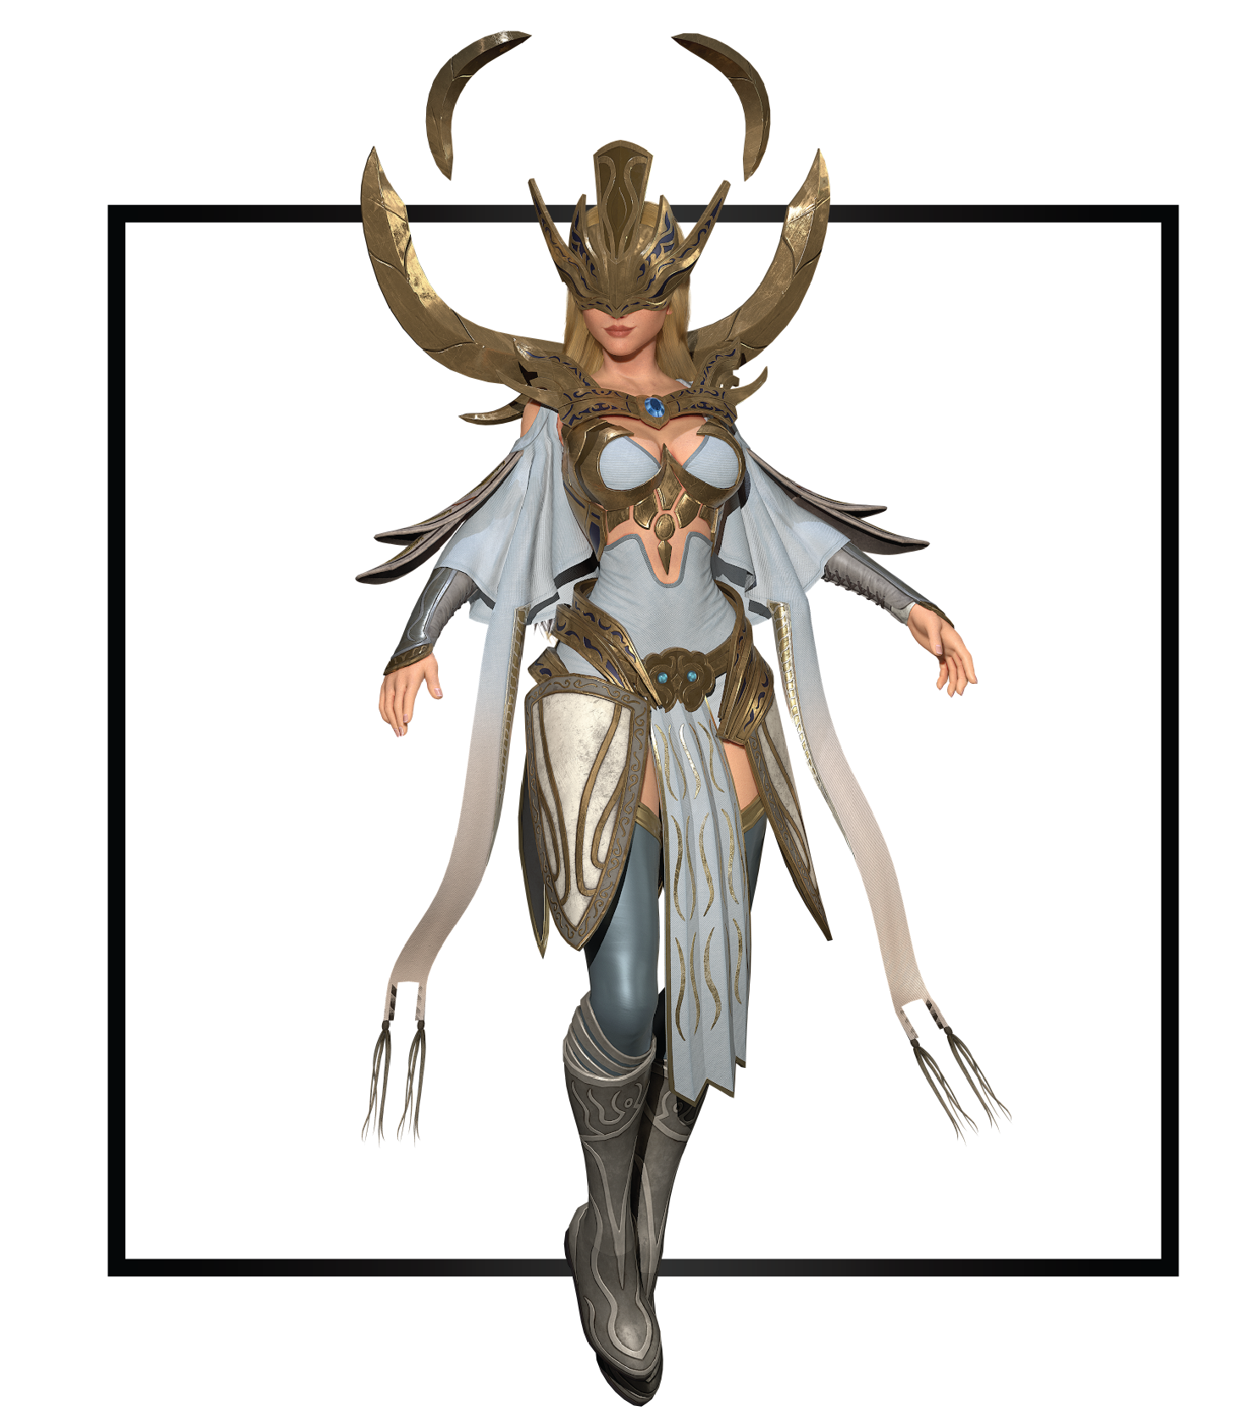

|  |  |
| --- | --- |
| **Name** | Noxus |
| **Title** | Seer of Light |
| **Realm** | Edolas |
| **Region** | Solarium |
| **Class** | Archmage |
| **Type** | Ranged Magical |
| **Release Date** | Coming Soon |

Chosen by Marah as the Seer of Light, Noxus reluctantly leads Solarium’s magical army against the creatures of the night. Upon her selection as Seer, she inherited a wealth of information regarding the safekeeping of her city and its people. Since its foundation, Solarium has been protected from all the dangers of the surrounding Desolation using a spectrum shield. Ancient crystals powered the light protection until they began to wane, threatening to expose everyone to the burning heat of Desolation, dooming the entire civilization.

Within the shield barrier, the magic-wielding inhabitants faced their own imminent downfall as misinformation spread of a new disease that drains the magic of its victims. In charge of protecting the future of Solarium, Noxus searches for ways to secure the future of her people and of her city.